**Assisted Practice: 3.7 Directives**

This section will guide you to:

* Implement Angular directives

This lab has four subsections, namely:

3.7.1 Creating a directive

3.7.2 Declaring the directive

3.7.3 Adding the directive as a property

3.7.4 Pushing the code to Github repositories

**Step 3.7.1:** Creating a directive

* Change the color of the tag.

### 

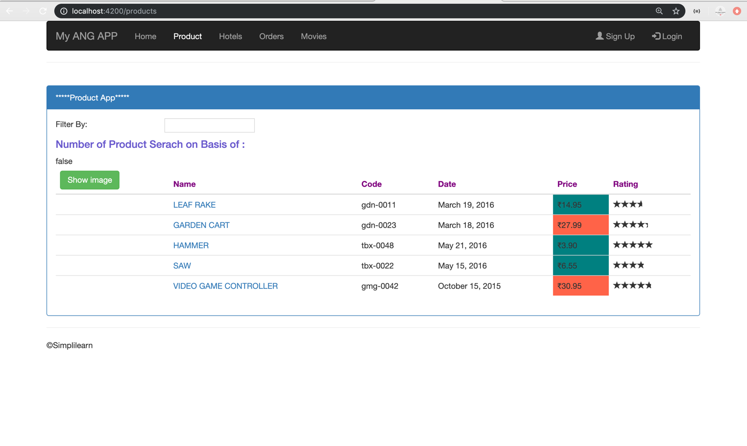

* Open Visual Studio Code
* Add the color property with the help of *ElementRef*.

// Required services for custom directives

import { Directive, ElementRef, Renderer2 } from '@angular/core';

@Directive({

  selector: '[appChangeColor]' // Directive selector

})

export class ChangeColorDirective {

  constructor(elem: ElementRef, renderer: Renderer2) {

    renderer.setStyle(elem.nativeElement, 'color', 'olive');

  }

}

**Step 3.7.2:** Declaring the directive

* Declare the directive in declaration array.

import { ChangeColorDirective } from './ChangeColor.directive';

@NgModule({

    imports: [

        SharedModule,

        AppRoutingModule

    ],

    declarations: [

        ChangeColorDirective,

        ProductComponent,

        MyUpperPipe,

        DiscountPipe,

        ProductSearch,

        ProductDetailComponent

    ],

**Step 3.7.3:** Adding the directive as a property

* Add the created directive as a property.

 <h4 appChangeColor>Number of Product Serach on Basis of {{userInput}}:</h4>

**Output:**

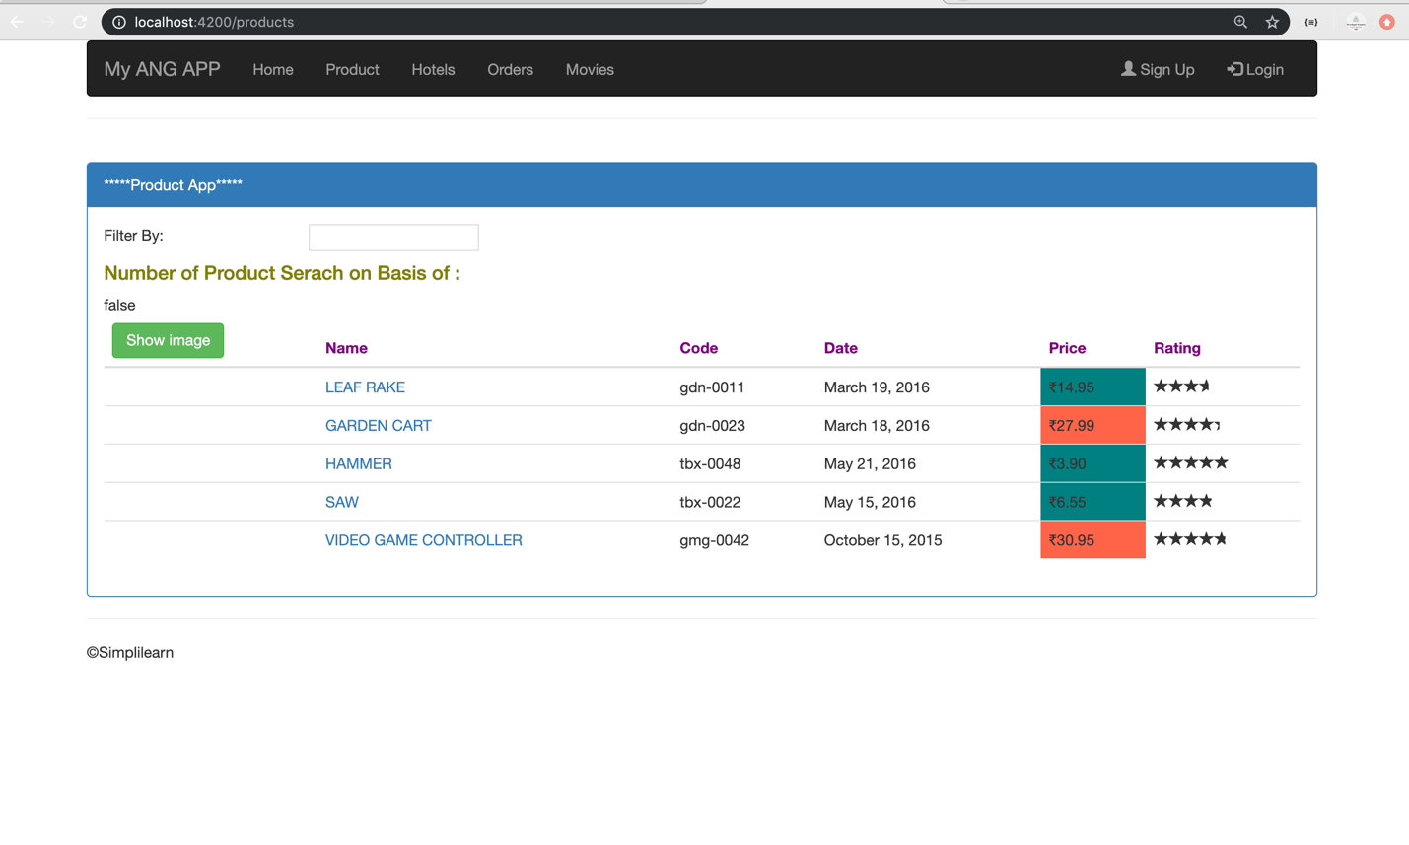

**Step 3.7.4:** Pushing the code to your GitHub repositories

* Open your command prompt and navigate to the folder where you have created your files.

**cd <folder path>**

* Initialize your repository using the following command:

**git init**

* Add all the files to your git repository using the following command:

**git add .**

* Commit the changes using the following command:

**git commit . -m “Changes have been committed.”**

* Push the files to the folder you initially created using the following command:

**git push -u origin master**